**Assumption: Column “Profit” from Data file means Gross Profit

- Can you tell us more about our customers and their spending habits?
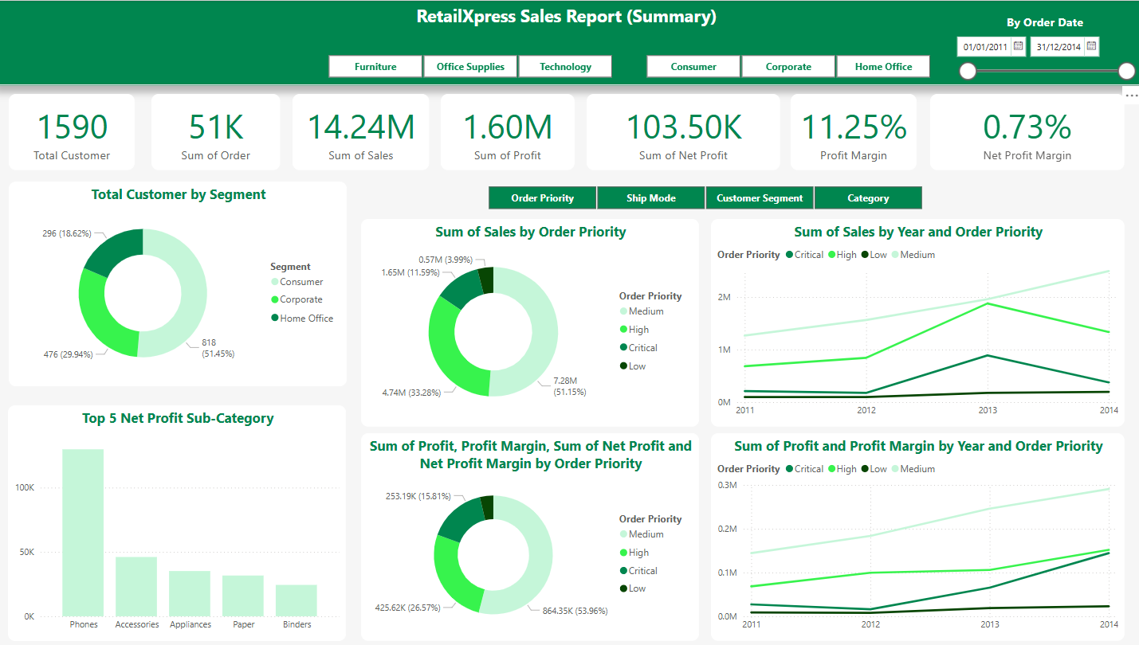
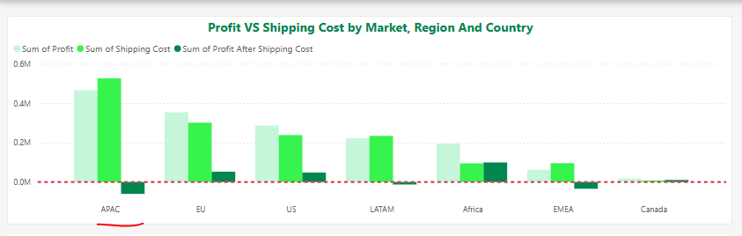
Briefly showing as below
- Customer By Segment
We have 3 segments of customers
- Sales By Category
Technology is the most favourite category especially Home Office and Corporate Customers
- Sales By Market
APAC is the largest market.
- Sales By Ship Mode
Most of the customer choose standard class
- Priority
Most of the order priority is Medium

- Which product categories should we continue to sell, and which should we discontinue?

- Continue to sell: 37.99% Technology Sales Amount contribute half of the profit, and the Profit trending is the best, we should continue to sell Technology Product. Office Supplies not outstanding but it’s still in profit, we should continue as well.
- Discontinue to sell: 29.08% Furniture sales amount contribute 18.13% profit only, and it’s the only category with negative net profit margin, maybe we should consider discontinuing this category.
- Additional findings, phone and Accessories with highest net profit, maybe we could focus on this sub-category as well.
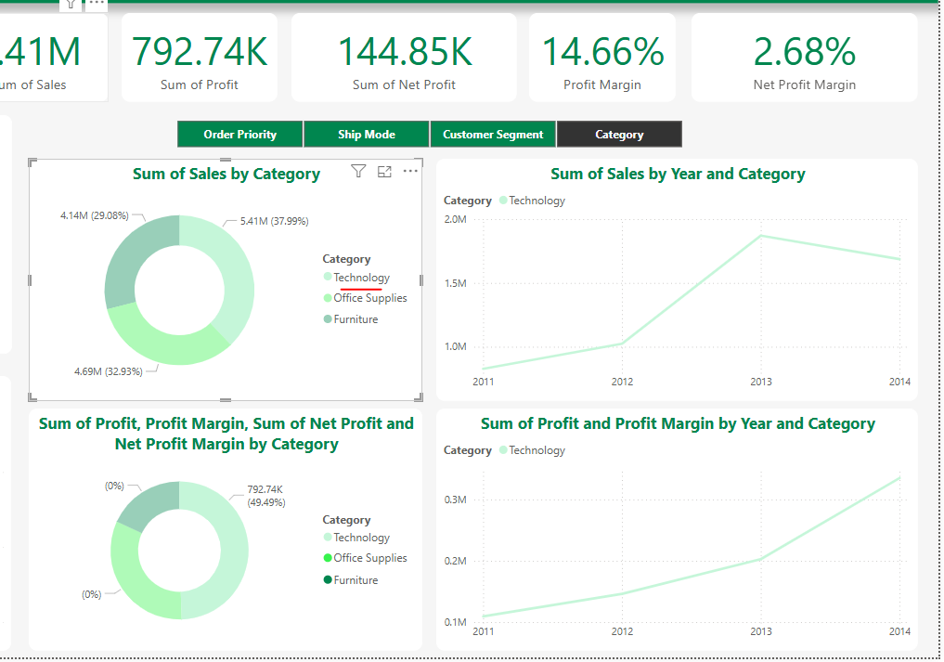
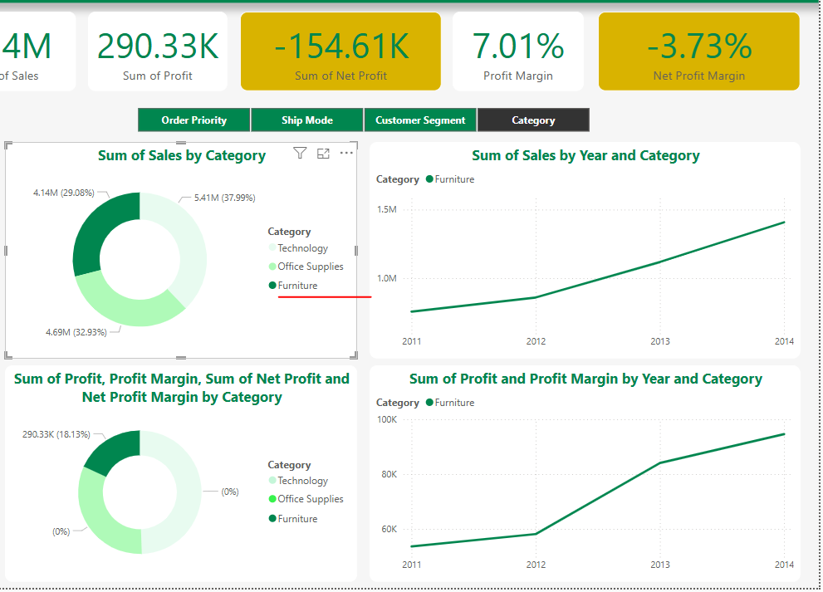

3.) Would it be beneficial to invest in a strategy to target high value, high risk customers to improve their satisfaction and reduce churn?
Ship Mode “Same Day” affects the Average Score the most
However, the Net Profit Margin is -3.88% while the profit increase sharply. IF we could invest in logistic to lower the Shipping cost, it’s worth us to invest in it to improve customer satisfaction, otherwise, we should not take any action first.
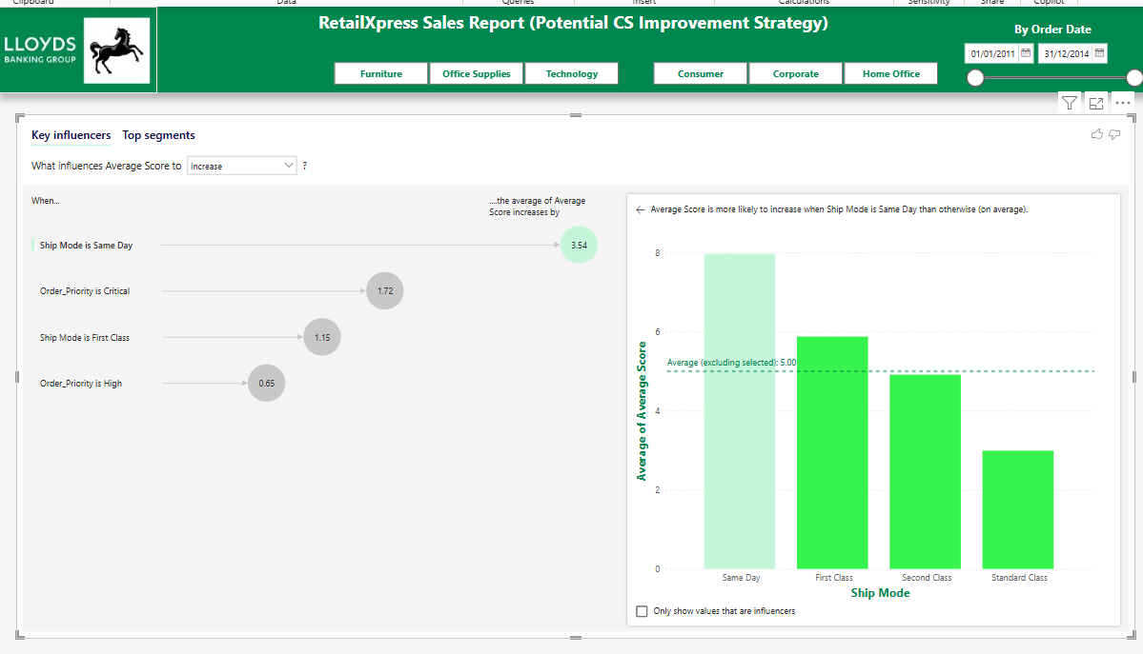
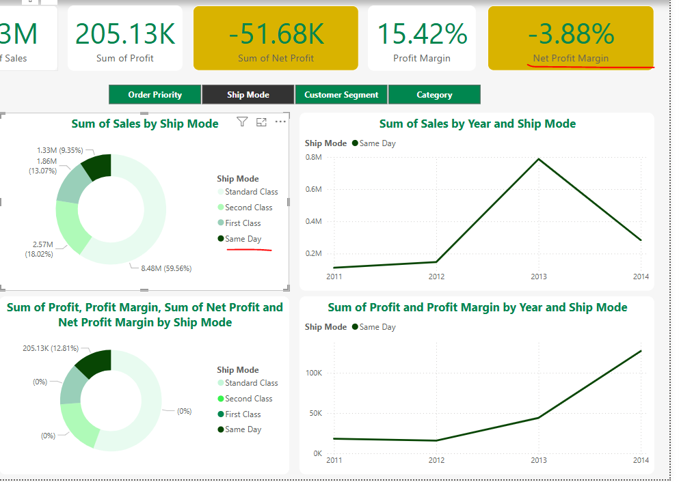

4.) If we were to create distribution hubs in countries to reduce shipping costs, which countries should we target? What effect will that have on our profit margins?
While we have huge Sales Amount in APAC and LATAM, we have loss in both Market.
In Oceania, we could see New Zealand has a huge loss after shipping and Australia almost loss all the profit on shipping. When these two countries are both in top 3 highest shipping cost, we could invest a hub in both countries.
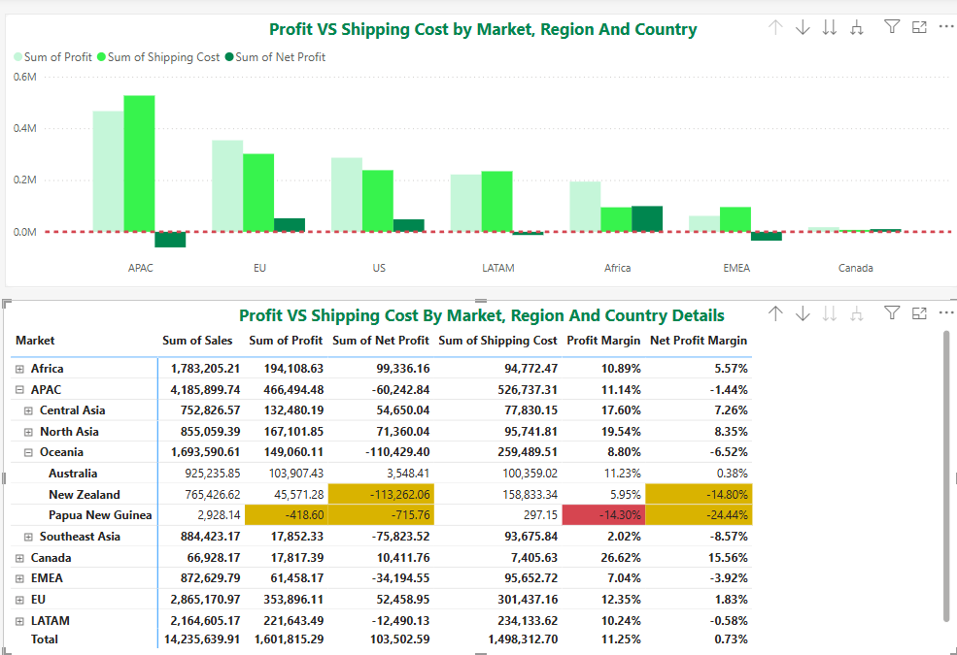
In Southeast Asia, we could see a loss after shipping in Indonesia, and the shipping cost is 281% of profit, we better to build a hub in this country.
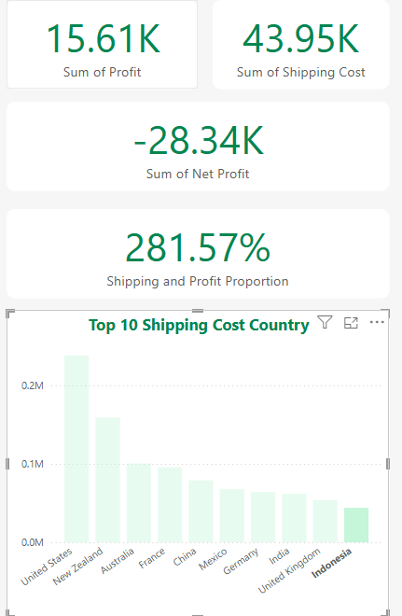
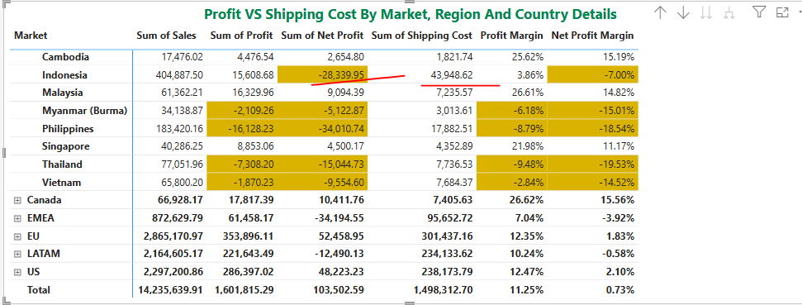
In South America, we should consider building a hub in Brazil as well.
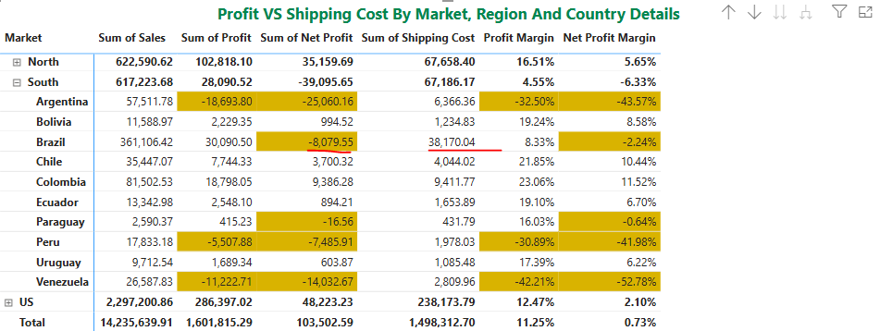

And US is the highest shipping cost country, worth to consider as well.
